Experiment 1
Aim - Introduction to Prolog.
What Is Prolog?
Prolog as the name itself suggests, is the short form of LOGical PROgramming. Prolog is a declarative programming language designed for developing logic-based AI applications. Developers can set rules and facts around a problem, and then Prolog’s interpreter will use that information to automatically infer solutions.
It’s a declarative programming language, meaning that it allows the programmer to specify the rules and facts about a problem domain, and then the Prolog interpreter will use these rules and facts to automatically infer solutions to problems.
Using Prolog
There is no single “syntax” for Prolog, as the language allows for a wide range of different programming styles and approaches. However, here are some basic elements of Prolog syntax that are commonly used:
- Facts are statements that are assumed to be true. In Prolog, facts are written using a predicate name followed by a list of arguments enclosed in parentheses. For example: man(john).
- Rules are logical statements that describe the relationships between different facts. In Prolog, rules are written using the predicate name followed by a list of arguments enclosed in parentheses, followed by a colon and a hyphen (:-) and the body of the rule. For example: not(X,Y) :- man(X), woman(Y).
- Variables are used to represent values that can change or be determined by the interpreter. In Prolog, variables are written using a name that begins with an uppercase letter. For example: X.
- Queries are used to ask the interpreter to find solutions to problems based on the rules and facts in the program. In Prolog, queries are written using the same syntax as facts followed by a question mark (?). For example: not(john, mary)?
Writing Facts in Prolog
Prolog facts are expressed in definite pattern. Facts contain entities and their relation. Entities are written within the parenthesis separated by comma (, ). Their relation is expressed at the start and outside the parenthesis. Every fact/rule ends with a dot (.).
% Facts
man(john).
woman(mary).
capital_of(france, paris).
Data types in Prolog
In Prolog, data types are not explicitly declared as they are in many other programming languages. Prolog is a logical programming language, and it uses a very flexible and dynamic approach to data. However, data in Prolog can be categorized in the following ways:
- Atoms:
Atoms are symbolic constants, which can be either simple identifiers or constants. Atoms start with a lowercase letter or are enclosed in single quotes (if they contain spaces or special characters).
  - Examples:
    - cat
    - 'Hello World'
    - apple_juice
- Numbers:
Prolog handles numbers in two forms:
  - Integers: Whole numbers, e.g., 42, -5
  - Floats: Decimal numbers, e.g., 3.14, -2.71
  - Example:
    - 42
    - -15
    - 3.14159
- Variables:
Variables represent placeholders and are used to match values during logical deductions. They begin with an uppercase letter or an underscore (_).
  - Examples:
    - X
    - Result
    - _
- Compound Terms:
These are structured terms that consist of a functor and a number of arguments. A compound term is written as Functor(Arg1, Arg2, ..., ArgN).
  - Example:
    - father(john, mary)
    - point(3, 4)
- Lists:
Lists are a fundamental data structure in Prolog and are written in the form [Head|Tail], where the Head is the first element and the Tail is the rest of the list (which can be another list or an empty list []).
  - Example:
    - [1, 2, 3]
    - [apple, banana, orange]
    - [Head|Tail]
- EmptyList:
The empty list is denoted as [] and is a special case of lists. It signifies a list with no elements.
  - Example:
    - [] (empty list)
- Strings:
Strings in Prolog are simply lists of characters (i.e., atoms), and are typically enclosed in double quotes.
  - Example:
    - "Hello"
    - "Prolog"
- Equality and Comparison:
Prolog can also handle comparisons and logical relations between variables and values (using =, \=, ==, \==, etc.).

Simple Prolog Program
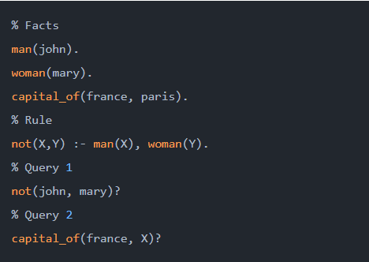
In this example, the program defines three facts: man(john), woman(mary), and capital_of(france, paris). These facts state that John is a man, Mary is a woman and Paris is the capital of France.
The program also defines a rule using the not/2 predicate. This rule states that if X is a man and Y is a woman, then X is not Y.
Finally, the program includes two queries. The first query, not(john, mary)?, asks the interpreter to determine whether John is not Mary, based on the not/2 rule and the man/1 and woman/1 facts. The interpreter will use these rules and facts to deduce that John is not Mary, and it will return true as the solution to the query.
The second query, capital_of(france, X)?, asks the interpreter to determine the capital of France. The interpreter will use the capital_of/2 fact to determine that the capital of France is Paris, and it will return the value paris for the variable X as the solution.
Some Applications of Prolog
Prolog is used in various domains. It plays a vital role in automation system. Following are some other important fields where Prolog is used −
- Intelligent Database Retrieval
- Natural Language Understanding
- Specification Language
- Machine Learning
- Robot Planning
- Automation System

Experiment 2

Aim – Write simple fact for the statements using Prolog.
- Ram likes mango.
- Seema is a girl.
- Bill likes Cindy.
- Rose is red.
- John owns gold.

Code:
likes(ram, mango).
likes(bill, cindy).
equals(seema, girl).
equals(roses, red).
owns(john, gold).

Queries:
?- likes(X, Y),
?- likes(K, cindy),
?- equals(roses, R),
?- equals(S, G),
?- owns(P, Q)

Output:
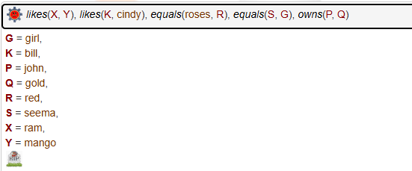

Experiment 3

Aim - Write predicates one convert centigrade temperatures to Fahrenheit the other checks if a temperature is below freezing using Prolog.
Code:
celsius_to_fahrenheit(C, F) :-
F is (C * 9 / 5) + 32.
below_freezing(Temp) :-
Temp < 0.

Queries:
?- celsius_to_fahrenheit(30, F).
?- below_freezing(-5).
?- below_freezing(10).

Output:
